Employee Database User Guide

**Starting the Database**

1. Launch the database program by double-clicking on “New_Employee_Database.jar”

The following window should appear.

**Navigating the Interface**

The database program is split into three sections, the entry fields, employee search and employee table.

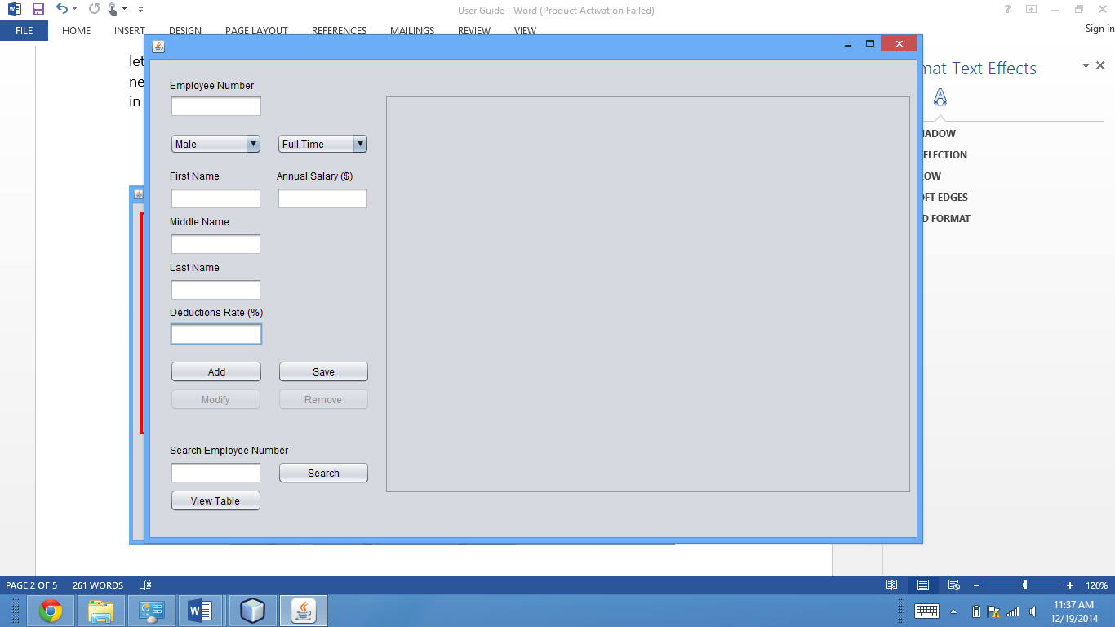

Entry Fields

This section contains all the information fields that allows new employees and their information to be added. Simply enter the appropriate information in each field and choose between full time and part time for each employee. Only enter the appropriate characters for each field (only letters for names, and number for employee number, salaries and deduction rates). Once all necessary information have been entered, press “Add” to store the information in the hash table and then “Save” to store the information from the hash table in the archive file.

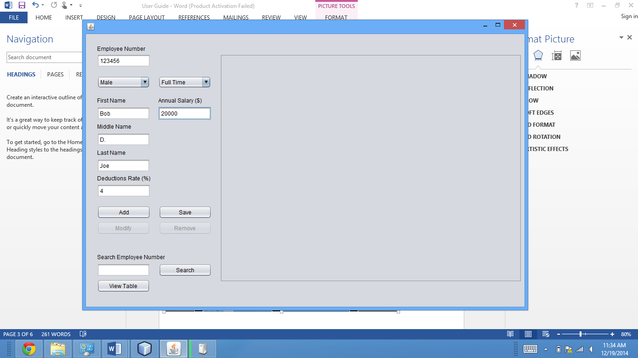

Employee Search

This section allows for existing employees to be searched. Type in an employee number and then press “Search” to view the results.

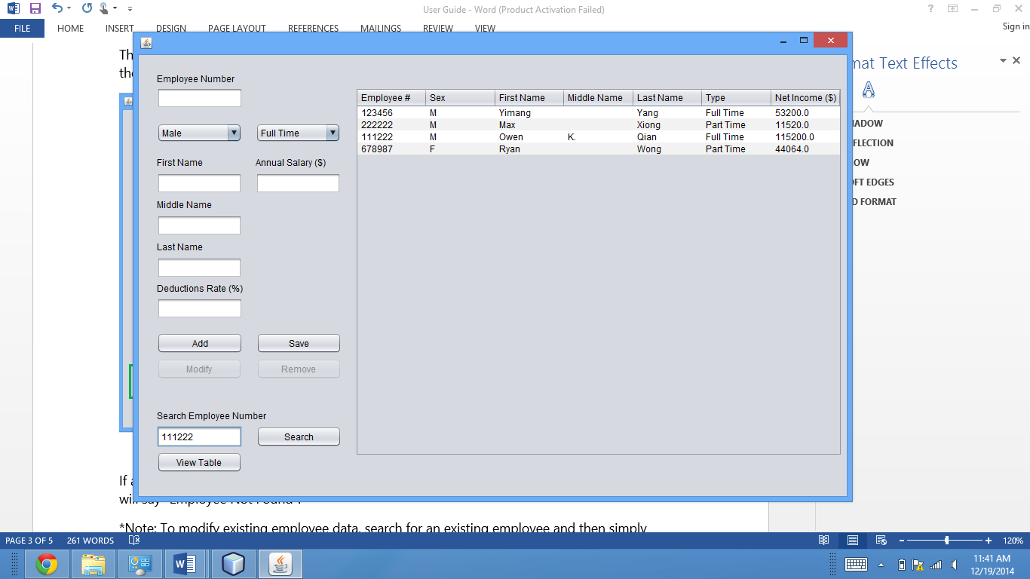

If an employee is found, the employee’s data will be shown in Section A. Otherwise, a message will say “Employee Not Found”.

*Note: To modify existing employee data, search for an existing employee and then simply change the fields found in Section A. Press “Modify” when all necessary changes are made. Press “Remove” to delete all information pertaining to the existing employee from the database. To exit the modify/remove mode without modifying any information, just press modify without making any changes to the information fields.

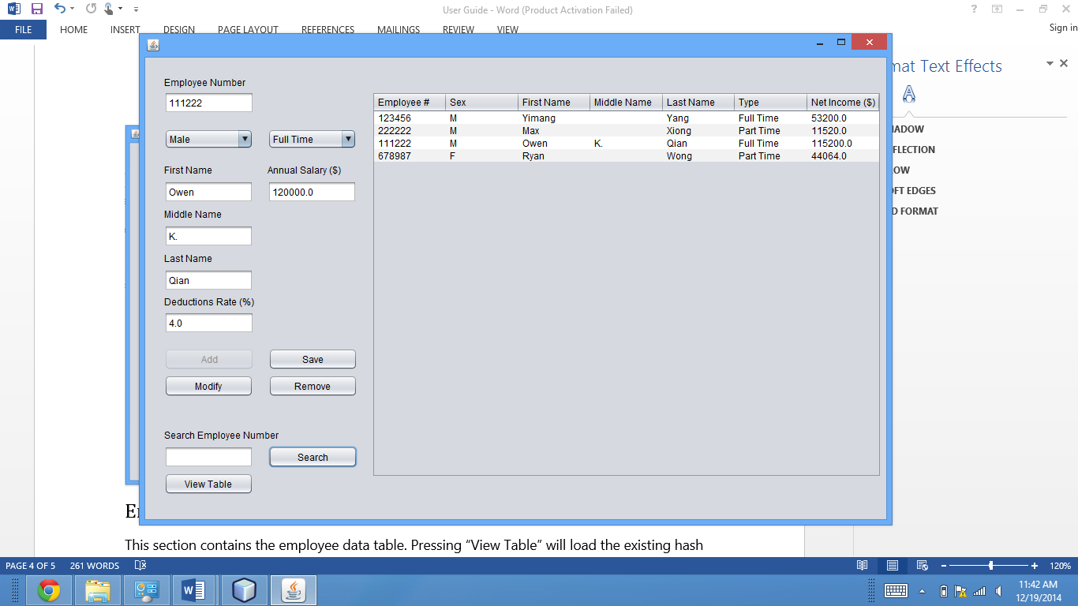

Employee Table

This section contains the employee data table. Pressing “View Table” will load the existing hash table and display employee information including employee number, sex, first name, middle name, last name, type and net income.

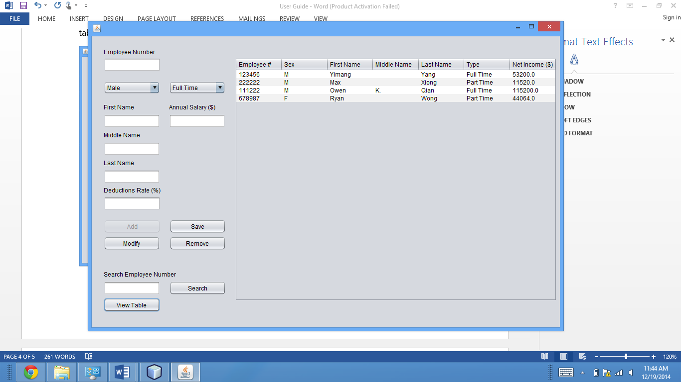

**Exiting the Program**

Upon closing the program window, a prompt will ask if you would like all changes to be saved into the archive file. Press “Yes” to save changes.

